## Week 4 Homework Submission File: Linux Systems Administration

### Step 1: Ensure/Double Check Permissions on Sensitive Files

1. Permissions on `/etc/shadow` should allow only `root` read and write access.

- Command to inspect permissions: **ls -l /etc/shadow**

- Command to set permissions (if needed): **Not needed**

2. Permissions on `/etc/gshadow` should allow only `root` read and write access.

- Command to inspect permissions: **ls -l /etc/gshadow**

- Command to set permissions (if needed): **Not needed**

3. Permissions on `/etc/group` should allow `root` read and write access, and allow everyone else read access only.

- Command to inspect permissions: **ls -l /etc/gshadow**

- Command to set permissions (if needed): **Not needed**

4. Permissions on `/etc/passwd` should allow `root` read and write access, and allow everyone else read access only.

- Command to inspect permissions: **ls -l /etc/passwd**

- Command to set permissions (if needed): **Not needed**

### Step 2: Create User Accounts

1. Add user accounts for `sam`, `joe`, `amy`, `sara`, and `admin`.

- Command to add each user account (include all five users):

**Sudo adduser sam**

**Sudo adduser joe**

**Sudo adduser amy**

**Sudo adduser sara**

**Sudo adduser admin**

2. Ensure that only the `admin` has general sudo access.

- Command to add `admin` to the `sudo` group:

**sudo usermod -aG sudo admin**

### Step 3: Create User Group and Collaborative Folder

1. Add an `engineers` group to the system.

- Command to add group: **sudo addgroup engineers**

2. Add users `sam`, `joe`, `amy`, and `sara` to the managed group.

- Command to add users to `engineers` group (include all four users):

**Sudo usermod -aG engineers sam**

**Sudo usermod -aG engineers joe**

**Sudo usermod -aG engineers amy**

**Sudo usermod -aG engineers sara**

3. Create a shared folder for this group at `/home/engineers`.

- Command to create the shared folder: **mkdir -p /home/engineers**

4. Change ownership on the new engineers' shared folder to the `engineers` group.

- Command to change ownership of engineer's shared folder to engineer group: **sudo chown :engineers /home/engineers**

### Step 4: Lynis Auditing

1. Command to install Lynis: **sudo apt install lynis**

2. Command to see documentation and instructions: **sudo lynis --help**

3. Command to run an audit: **sudo lynis audit system**

4. Provide a report from the Lynis output on what can be done to harden the system.

- Screenshot of report output:

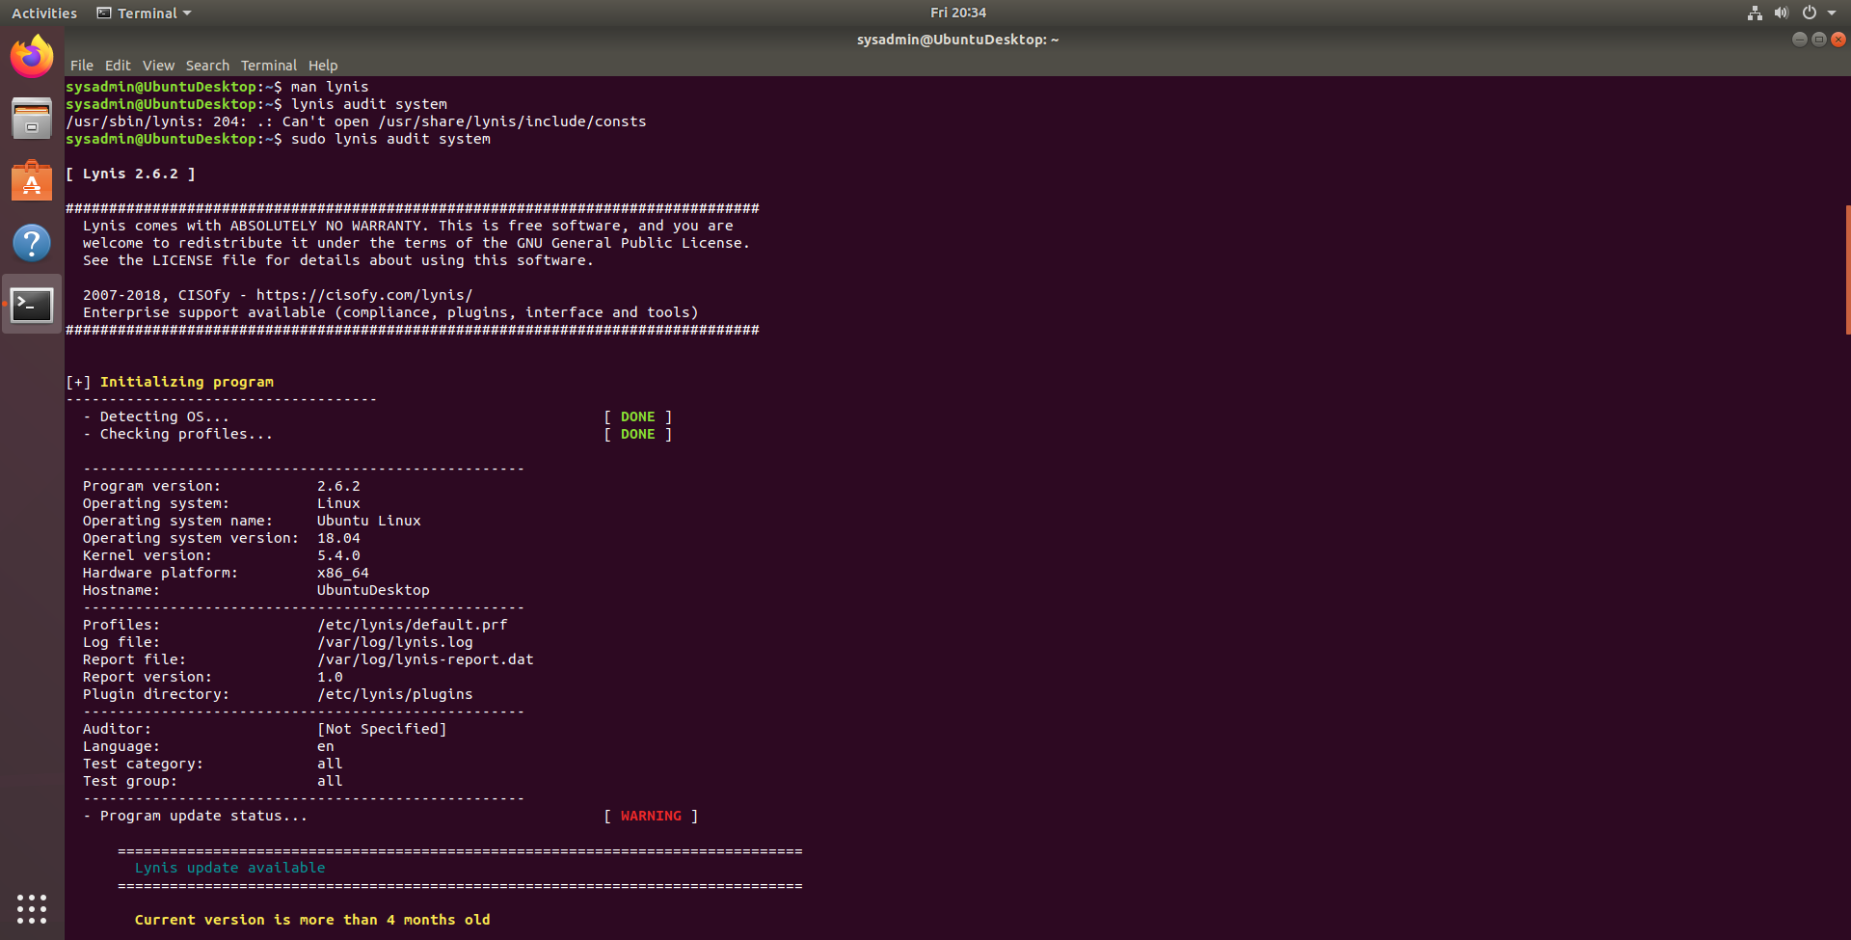

### Bonus

1. Command to install chkrootkit: **sudo apt install chkrootkit**

2. Command to see documentation and instructions: **chkrootkit --help**

3. Command to run expert mode: **sudo chkrootkit -x**

4. Provide a report from the chrootkit output on what can be done to harden the system.

- Screenshot of end of sample output: 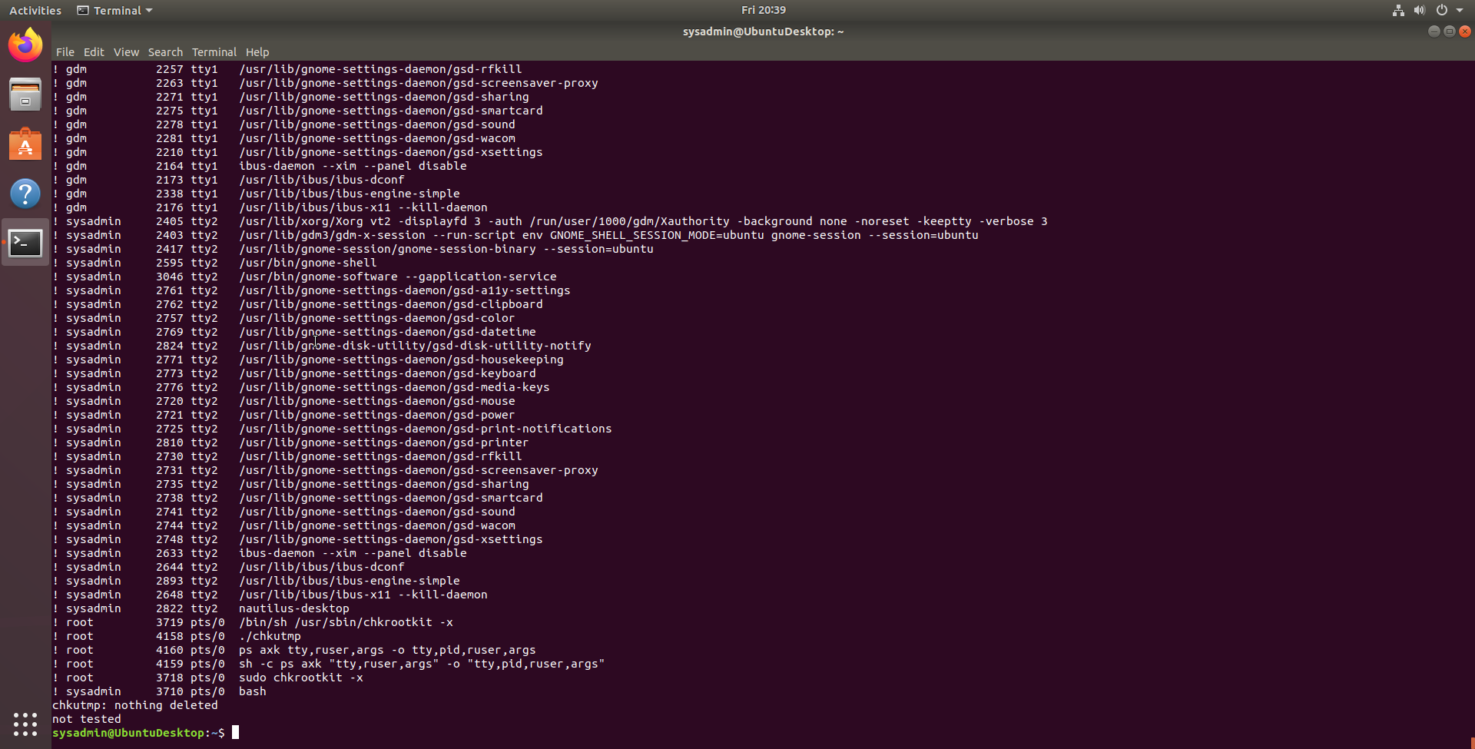

---

© 2020 Trilogy Education Services, a 2U, Inc. brand. All Rights Reserved.